Учет обилия мусора на супралиторали о. Ряжкова в 2022-2023 гг.

В. М. Хайтов

**Хайтов В. М. Учет обилия мусора на супралиторали о. Ряжкова в 2022-2023 гг.** // Толмачева Е. Л. (ред.) Летопись природы Кандалакшского заповедника за 2016 год (ежегодный отчет). Кандалакша. Т.1 (Летопись природы Кандалакшского заповедника кн. ++)

Проведен количественный анализ обилия антропогенного мусора на побережье о. Ряжкова.

**Khaitov V.M. The assessment of litter on the Ryazhkov island shore-line in 2022-2023** // Tolmacheva E. L. (ed.) The Chronicle of Nature by the Kandalaksha Reserve for 2016 (Annual report). Kandalaksha. V.1. (The Chronicle of Nature by the Kandalaksha Reserve Book N ++)

The results of quantitative analysis of litter presented on shore of Ryazhkov island are presented.

Учет мусора производился в полосе штормовых выбросов. При этом отмечались все предметы заметные без разрушения слоя выбросов. Единицей учета были отдельные предметы или их части представленные в выбросах как единое целое. Координаты точки начала учета засекалась с помощью GPS-навигатора. Исходные данные по учету предметов антропогенного происхождения за 2022-2023 гг приведены в таблице +.1. Данные по обилию мусора в 2008-2019 гг были приведены в Летописи природы за 2016 и 2019 гг.

Как показали анализы проведенные в предыдущие годы наиболее объективным показателем отражающим обилие мусора является количество пластиковых бутылок. Обилие этих предметов можно рассматривать как маркер обилия мусора. В таблице +.2 приведены данные по суммарному количеству пластиковых бутылок и прочего антропогенного мусора на побережье о. Ряжкова. График (Рисунок 1) отражающий межгодовые изменения общего количества пластиковых бутылок и прочих предметов обнаруженных на побережье о. Ряжкова не демонстрирует явных многолетних тенденций. В последние годы эти величины поддерживаются на более или менее одинаковом уровне.

Для анализа пространственного распределения мусора по побережью о. Ряжкова были построены карты (Рисунок 2) на которых нанесены участки учета мусора и приведены данные по обилию пластиковых бутылок. Можно заметить что год от года паттерн распределения обилия пластиковых бутылок изменяется. Наибольшее количество пластиковых бутылок наблюдалось в Северо-Западной части острова и в Фукусовой губе (Юго-Восточная часть).

Таблица +.1 Количество предметов антропогенного мусора найденных на разных станциях на побережье о. Ряжкова в 2022-2023 гг. Number of antropogenic items found on the stations on Ryazhkov island shore in 2022-2023.

| Год | Широта | Долгота | Плас-тиковые предме-ты | Плас-тико-вые бутыл-ки | Стекло | По-лиэтилен | Резино-вые предме-ты | Бу-мага | Ме-талл | Консерв-ные банки | Пред-меты одеж-ды | Пено-пласт | Проч. |
| --- | --- | --- | --- | --- | --- | --- | --- | --- | --- | --- | --- | --- | --- |
| 2022 | 67.00738 | 32.57737 | 0 | 1 | 0 | 3 | 0 | 0 | 0 | 0 | 0 | 0 | 1 |
| 2022 | 67.00715 | 32.57880 | 0 | 0 | 0 | 0 | 0 | 0 | 0 | 0 | 0 | 0 | 0 |
| 2022 | 67.00780 | 32.58025 | 0 | 0 | 0 | 0 | 0 | 0 | 0 | 0 | 0 | 0 | 0 |
| 2022 | 67.00817 | 32.58135 | 0 | 4 | 0 | 7 | 0 | 0 | 1 | 0 | 0 | 1 | 0 |
| 2022 | 67.00855 | 32.58310 | 10 | 2 | 0 | 58 | 0 | 0 | 0 | 0 | 0 | 0 | 0 |
| 2022 | 67.00833 | 32.58463 | 7 | 0 | 7 | 23 | 0 | 0 | 0 | 0 | 0 | 1 | 0 |
| 2022 | 67.00775 | 32.58585 | 0 | 0 | 0 | 0 | 0 | 0 | 0 | 0 | 0 | 0 | 0 |
| 2022 | 67.00813 | 32.58760 | 0 | 0 | 0 | 0 | 0 | 0 | 0 | 0 | 0 | 0 | 0 |
| 2022 | 67.00872 | 32.58818 | 0 | 0 | 0 | 0 | 0 | 0 | 0 | 0 | 0 | 0 | 0 |
| 2022 | 67.00962 | 32.58833 | 0 | 0 | 0 | 0 | 0 | 0 | 0 | 0 | 0 | 0 | 0 |
| 2022 | 67.01025 | 32.58825 | 0 | 0 | 1 | 0 | 0 | 0 | 0 | 0 | 0 | 0 | 0 |
| 2022 | 67.01067 | 32.58838 | 0 | 0 | 1 | 0 | 0 | 0 | 0 | 0 | 0 | 0 | 1 |
| 2022 | 67.01120 | 32.58783 | 3 | 0 | 1 | 0 | 0 | 0 | 0 | 0 | 0 | 2 | 0 |
| 2022 | 67.01167 | 32.58703 | 0 | 0 | 0 | 2 | 0 | 0 | 0 | 0 | 2 | 1 | 1 |
| 2022 | 67.01235 | 32.58655 | 1 | 0 | 0 | 1 | 0 | 0 | 0 | 0 | 0 | 0 | 0 |
| 2022 | 67.01285 | 32.58543 | 0 | 1 | 0 | 0 | 0 | 0 | 0 | 0 | 0 | 0 | 3 |
| 2022 | 67.01368 | 32.58478 | 0 | 1 | 0 | 1 | 0 | 0 | 0 | 0 | 0 | 0 | 0 |
| 2022 | 67.01443 | 32.58437 | 0 | 1 | 0 | 0 | 0 | 0 | 0 | 0 | 0 | 0 | 0 |
| 2022 | 67.01480 | 32.58392 | 2 | 0 | 0 | 0 | 0 | 0 | 0 | 0 | 0 | 0 | 2 |
| 2022 | 67.01555 | 32.58277 | 2 | 0 | 0 | 2 | 0 | 0 | 1 | 0 | 0 | 0 | 2 |
| 2022 | 67.01602 | 32.58070 | 0 | 2 | 0 | 2 | 2 | 0 | 0 | 0 | 0 | 1 | 1 |
| 2022 | 67.01637 | 32.57943 | 1 | 1 | 0 | 0 | 0 | 0 | 0 | 1 | 0 | 0 | 0 |
| 2022 | 67.01700 | 32.57812 | 0 | 1 | 0 | 0 | 0 | 0 | 0 | 0 | 0 | 1 | 0 |
| 2022 | 67.01807 | 32.57775 | 0 | 2 | 1 | 0 | 0 | 0 | 0 | 0 | 0 | 2 | 0 |
| 2022 | 67.01910 | 32.57645 | 0 | 0 | 0 | 0 | 0 | 0 | 0 | 0 | 0 | 1 | 0 |
| 2022 | 67.01935 | 32.57487 | 0 | 0 | 0 | 0 | 0 | 0 | 0 | 0 | 0 | 0 | 0 |
| 2022 | 67.01948 | 32.57332 | 0 | 1 | 0 | 1 | 0 | 0 | 0 | 0 | 0 | 2 | 0 |
| 2022 | 67.01978 | 32.57033 | 0 | 2 | 0 | 6 | 0 | 0 | 0 | 0 | 0 | 0 | 0 |
| 2022 | 67.02042 | 32.56938 | 1 | 3 | 0 | 4 | 1 | 0 | 0 | 0 | 0 | 0 | 0 |
| 2022 | 67.02145 | 32.56832 | 1 | 1 | 0 | 0 | 1 | 0 | 0 | 0 | 0 | 0 | 0 |
| 2022 | 67.02188 | 32.56800 | 0 | 0 | 0 | 0 | 0 | 0 | 0 | 0 | 0 | 0 | 0 |
| 2022 | 67.02315 | 32.56772 | 0 | 0 | 0 | 0 | 0 | 0 | 0 | 0 | 0 | 0 | 0 |
| 2022 | 67.02417 | 32.56668 | 0 | 0 | 0 | 0 | 0 | 0 | 2 | 0 | 0 | 0 | 0 |
| 2022 | 67.02472 | 32.56663 | 0 | 0 | 0 | 0 | 0 | 0 | 0 | 0 | 0 | 0 | 0 |
| 2022 | 67.02512 | 32.56588 | 0 | 0 | 0 | 0 | 0 | 0 | 0 | 0 | 0 | 0 | 0 |
| 2022 | 67.02567 | 32.56435 | 0 | 0 | 0 | 0 | 0 | 0 | 0 | 0 | 0 | 0 | 0 |
| 2022 | 67.02622 | 32.56252 | 0 | 0 | 0 | 0 | 0 | 0 | 0 | 0 | 0 | 0 | 0 |
| 2022 | 67.02682 | 32.56087 | 0 | 0 | 0 | 0 | 0 | 0 | 0 | 0 | 0 | 0 | 0 |
| 2022 | 67.02745 | 32.56110 | 0 | 0 | 0 | 0 | 0 | 0 | 0 | 0 | 0 | 0 | 0 |
| 2022 | 67.02792 | 32.55805 | 0 | 0 | 0 | 0 | 0 | 0 | 0 | 0 | 0 | 0 | 0 |
| 2022 | 67.02852 | 32.55677 | 0 | 0 | 0 | 0 | 0 | 0 | 0 | 0 | 0 | 0 | 0 |
| 2022 | 67.02920 | 32.55585 | 0 | 0 | 0 | 0 | 0 | 0 | 0 | 0 | 0 | 0 | 0 |
| 2022 | 67.02977 | 32.55483 | 0 | 0 | 0 | 0 | 0 | 0 | 0 | 0 | 0 | 0 | 0 |
| 2022 | 67.03032 | 32.55320 | 0 | 0 | 0 | 0 | 0 | 0 | 0 | 0 | 0 | 0 | 0 |
| 2022 | 67.03093 | 32.55158 | 2 | 5 | 0 | 3 | 0 | 0 | 0 | 0 | 0 | 0 | 0 |
| 2022 | 67.03148 | 32.54852 | 0 | 0 | 1 | 0 | 2 | 0 | 0 | 0 | 0 | 1 | 0 |
| 2022 | 67.03195 | 32.54648 | 1 | 0 | 0 | 0 | 0 | 0 | 0 | 0 | 0 | 0 | 0 |
| 2022 | 67.03195 | 32.54502 | 1 | 2 | 0 | 0 | 0 | 0 | 2 | 0 | 0 | 0 | 0 |
| 2022 | 67.03172 | 32.54328 | 2 | 5 | 0 | 1 | 1 | 0 | 0 | 0 | 0 | 1 | 21 |
| 2022 | 67.03103 | 32.54138 | 4 | 2 | 0 | 4 | 0 | 0 | 0 | 0 | 0 | 0 | 2 |
| 2022 | 67.03075 | 32.53993 | 0 | 2 | 1 | 1 | 0 | 0 | 0 | 0 | 0 | 1 | 0 |
| 2022 | 67.02993 | 32.54028 | 0 | 0 | 0 | 0 | 0 | 0 | 0 | 0 | 0 | 0 | 0 |
| 2022 | 67.02908 | 32.54038 | 0 | 0 | 0 | 1 | 0 | 0 | 0 | 0 | 0 | 0 | 0 |
| 2022 | 67.02763 | 32.54105 | 4 | 8 | 2 | 1 | 1 | 0 | 1 | 0 | 0 | 1 | 0 |
| 2022 | 67.02713 | 32.54153 | 0 | 0 | 0 | 0 | 0 | 0 | 0 | 0 | 0 | 0 | 0 |
| 2022 | 67.02638 | 32.54190 | 0 | 0 | 0 | 0 | 0 | 0 | 0 | 0 | 0 | 0 | 0 |
| 2022 | 67.02557 | 32.54203 | 0 | 0 | 0 | 0 | 0 | 0 | 0 | 0 | 0 | 0 | 0 |
| 2022 | 67.02440 | 32.54240 | 0 | 0 | 0 | 14 | 0 | 0 | 0 | 0 | 0 | 0 | 0 |
| 2022 | 67.02402 | 32.54305 | 5 | 1 | 0 | 49 | 0 | 0 | 0 | 0 | 1 | 0 | 3 |
| 2022 | 67.02443 | 32.54157 | 0 | 0 | 0 | 0 | 0 | 0 | 0 | 0 | 0 | 0 | 0 |
| 2022 | 67.02492 | 32.53963 | 0 | 2 | 1 | 2 | 0 | 0 | 1 | 0 | 0 | 0 | 1 |
| 2022 | 67.02553 | 32.53850 | 0 | 2 | 0 | 2 | 0 | 0 | 1 | 0 | 0 | 0 | 1 |
| 2022 | 67.02632 | 32.53752 | 0 | 0 | 0 | 0 | 0 | 0 | 4 | 0 | 0 | 0 | 2 |
| 2022 | 67.02700 | 32.53642 | 0 | 0 | 0 | 0 | 0 | 0 | 0 | 1 | 0 | 0 | 0 |
| 2022 | 67.02742 | 32.53432 | 0 | 0 | 0 | 4 | 1 | 0 | 1 | 0 | 1 | 0 | 4 |
| 2022 | 67.02800 | 32.53280 | 3 | 1 | 0 | 7 | 0 | 0 | 0 | 0 | 0 | 0 | 0 |
| 2022 | 67.02827 | 32.53072 | 0 | 0 | 0 | 0 | 0 | 0 | 0 | 0 | 0 | 0 | 0 |
| 2022 | 67.02750 | 32.53002 | 1 | 0 | 0 | 1 | 0 | 0 | 0 | 0 | 0 | 0 | 0 |
| 2022 | 67.02698 | 32.53027 | 0 | 2 | 0 | 5 | 0 | 0 | 0 | 0 | 0 | 0 | 1 |
| 2022 | 67.02610 | 32.53052 | 0 | 0 | 0 | 2 | 0 | 0 | 0 | 0 | 0 | 0 | 0 |
| 2022 | 67.02525 | 32.53022 | 0 | 1 | 0 | 1 | 0 | 0 | 0 | 0 | 0 | 0 | 1 |
| 2022 | 67.02438 | 32.53013 | 0 | 4 | 0 | 5 | 0 | 0 | 0 | 2 | 0 | 0 | 2 |
| 2022 | 67.02363 | 32.52987 | 1 | 4 | 0 | 4 | 0 | 0 | 0 | 0 | 1 | 0 | 8 |
| 2022 | 67.02272 | 32.52955 | 0 | 2 | 0 | 3 | 0 | 1 | 0 | 0 | 0 | 0 | 0 |
| 2022 | 67.02198 | 32.53015 | 2 | 2 | 0 | 4 | 1 | 0 | 0 | 0 | 0 | 0 | 0 |
| 2022 | 67.02142 | 32.52970 | 0 | 1 | 0 | 2 | 2 | 0 | 0 | 0 | 0 | 0 | 0 |
| 2022 | 67.02068 | 32.53023 | 0 | 0 | 0 | 5 | 3 | 0 | 0 | 0 | 0 | 0 | 0 |
| 2022 | 67.01992 | 32.53113 | 2 | 0 | 0 | 4 | 2 | 0 | 0 | 0 | 0 | 0 | 1 |
| 2022 | 67.01897 | 32.53238 | 4 | 0 | 0 | 0 | 0 | 0 | 0 | 0 | 0 | 6 | 2 |
| 2022 | 67.01787 | 32.53477 | 2 | 0 | 0 | 11 | 3 | 0 | 0 | 0 | 0 | 0 | 2 |
| 2022 | 67.01718 | 32.53517 | 4 | 2 | 0 | 20 | 0 | 0 | 0 | 0 | 0 | 0 | 3 |
| 2022 | 67.01655 | 32.53638 | 3 | 3 | 1 | 10 | 0 | 0 | 0 | 2 | 0 | 0 | 3 |
| 2022 | 67.01587 | 32.53787 | 2 | 1 | 0 | 5 | 0 | 0 | 1 | 1 | 0 | 0 | 4 |
| 2022 | 67.01510 | 32.53878 | 0 | 2 | 0 | 9 | 0 | 0 | 0 | 1 | 0 | 0 | 3 |
| 2022 | 67.01435 | 32.53985 | 1 | 4 | 1 | 8 | 0 | 0 | 0 | 0 | 0 | 0 | 4 |
| 2022 | 67.01370 | 32.54107 | 6 | 0 | 0 | 2 |  | 1 | 0 | 0 | 0 | 0 | 1 |
| 2022 | 67.01310 | 32.54282 | 2 | 0 | 0 | 1 | 1 | 0 | 0 | 0 | 0 | 0 | 0 |
| 2022 | 67.01247 | 32.54435 | 2 | 0 | 0 | 3 | 0 | 0 | 0 | 0 | 0 | 0 | 0 |
| 2022 | 67.01188 | 32.54603 | 0 | 0 | 0 | 9 | 0 | 0 | 0 | 0 | 0 | 0 | 1 |
| 2022 | 67.01127 | 32.54757 | 2 | 0 | 1 | 4 | 2 | 1 | 0 | 0 | 1 | 0 | 2 |
| 2022 | 67.01060 | 32.54873 | 2 | 1 | 0 | 6 | 0 | 0 | 0 | 0 | 0 | 0 | 2 |
| 2022 | 67.00967 | 32.55113 | 1 | 1 | 0 | 6 | 0 | 0 | 0 | 0 | 1 | 0 | 1 |
| 2022 | 67.00883 | 32.55353 | 1 | 1 | 1 | 6 | 0 | 0 | 1 | 0 | 0 | 0 | 1 |
| 2022 | 67.00828 | 32.55525 | 0 | 1 | 0 | 6 | 0 | 0 | 0 | 0 | 0 | 0 | 2 |
| 2022 | 67.00765 | 32.55638 | 1 | 2 | 0 | 0 | 0 | 0 | 0 | 0 | 0 | 0 | 0 |
| 2022 | 67.00705 | 32.55790 | 1 | 1 | 0 | 7 | 0 | 0 | 0 | 0 | 0 | 0 | 3 |
| 2022 | 67.00647 | 32.55890 | 1 | 0 | 0 | 2 | 0 | 0 | 0 | 0 | 1 | 0 | 3 |
| 2022 | 67.00608 | 32.56023 | 3 | 1 | 0 | 6 | 0 | 0 | 0 | 0 | 0 | 0 | 1 |
| 2022 | 67.00547 | 32.56158 | 0 | 0 | 0 | 1 | 0 | 0 | 0 | 0 | 0 | 0 | 1 |
| 2022 | 67.00487 | 32.56368 | 0 | 1 | 0 | 5 | 0 | 0 | 0 | 0 | 1 | 0 | 0 |
| 2022 | 67.00422 | 32.56493 | 0 | 0 | 0 | 1 | 0 | 0 | 0 | 0 | 1 | 0 | 5 |
| 2022 | 67.00425 | 32.56822 | 0 | 0 | 0 | 4 | 0 | 0 | 0 | 0 | 0 | 0 | 2 |
| 2022 | 67.00395 | 32.57027 | 0 | 0 | 0 | 0 | 0 | 0 | 0 | 0 | 0 | 0 | 2 |
| 2022 | 67.00362 | 32.57215 | 0 | 0 | 0 | 0 | 0 | 0 | 0 | 0 | 0 | 0 | 3 |
| 2022 | 67.00373 | 32.57345 | 0 | 1 | 0 | 1 | 0 | 0 | 0 | 0 | 0 | 0 | 0 |
| 2022 | 67.00390 | 32.57445 | 0 | 0 | 0 | 0 | 0 | 0 | 0 | 0 | 0 | 0 | 0 |
| 2022 | 67.00470 | 32.57405 | 0 | 1 | 0 | 5 | 0 | 0 | 0 | 0 | 0 | 0 | 0 |
| 2022 | 67.00525 | 32.57292 | 3 | 1 | 0 | 19 | 0 | 0 | 0 | 0 | 0 | 0 | 0 |
| 2022 | 67.00648 | 32.57013 | 1 | 1 | 0 | 13 | 1 | 0 | 0 | 0 | 0 | 0 | 0 |
| 2022 | 67.00787 | 32.56977 | 2 | 0 | 0 | 18 | 0 | 0 | 0 | 0 | 0 | 0 | 0 |
| 2022 | 67.00840 | 32.56890 | 3 | 0 | 0 | 8 | 0 | 0 | 0 | 0 | 0 | 0 | 0 |
| 2022 | 67.00923 | 32.56888 | 2 | 0 | 0 | 14 | 0 | 0 | 0 | 0 | 0 | 0 | 0 |
| 2022 | 67.00953 | 32.57040 | 2 | 0 | 0 | 18 | 0 | 0 | 0 | 0 | 0 | 0 | 0 |
| 2022 | 67.00947 | 32.57145 | 5 | 1 | 0 | 10 | 0 | 0 | 0 | 0 | 0 | 0 | 0 |
| 2022 | 67.00932 | 32.57243 | 4 | 0 | 0 | 29 | 0 | 0 | 0 | 0 | 0 | 0 | 0 |
| 2022 | 67.00885 | 32.57447 | 7 | 0 | 0 | 11 | 0 | 0 | 0 | 0 | 0 | 0 | 0 |
| 2022 | 67.00850 | 32.57560 | 1 | 1 | 0 | 9 | 0 | 0 | 0 | 0 | 0 | 0 | 0 |
| 2022 | 67.00805 | 32.57600 | 0 | 0 | 0 | 0 | 0 | 0 | 0 | 0 | 0 | 0 | 0 |
| 2023 | 67.00738 | 32.57737 | 0 | 0 | 0 | 0 | 0 | 0 | 0 | 0 | 0 | 0 | 0 |
| 2023 | 67.00715 | 32.57880 | 0 | 3 | 0 | 2 | 0 | 0 | 1 | 0 | 0 | 0 | 0 |
| 2023 | 67.00780 | 32.58025 | 0 | 5 | 0 | 8 | 0 | 0 | 0 | 0 | 0 | 0 | 4 |
| 2023 | 67.00817 | 32.58135 | 0 | 0 | 0 | 0 | 0 | 0 | 0 | 1 | 0 | 0 | 0 |
| 2023 | 67.00855 | 32.58310 | 0 | 0 | 0 | 1 | 0 | 0 | 0 | 0 | 0 | 0 | 2 |
| 2023 | 67.00833 | 32.58463 | 0 | 3 | 0 | 0 | 0 | 0 | 0 | 0 | 0 | 0 | 0 |
| 2023 | 67.00775 | 32.58585 | 0 | 0 | 0 | 0 | 0 | 0 | 0 | 0 | 0 | 0 | 0 |
| 2023 | 67.00813 | 32.58760 | 0 | 0 | 0 | 0 | 0 | 0 | 0 | 0 | 0 | 0 | 0 |
| 2023 | 67.00872 | 32.58818 | 0 | 0 | 0 | 0 | 0 | 0 | 0 | 0 | 0 | 0 | 0 |
| 2023 | 67.00962 | 32.58833 | 0 | 0 | 0 | 0 | 0 | 0 | 0 | 0 | 0 | 0 | 0 |
| 2023 | 67.01025 | 32.58825 | 0 | 0 | 0 | 1 | 0 | 0 | 0 | 0 | 0 | 0 | 0 |
| 2023 | 67.01067 | 32.58838 | 0 | 0 | 0 | 0 | 0 | 0 | 0 | 0 | 0 | 0 | 0 |
| 2023 | 67.01120 | 32.58783 | 0 | 2 | 0 | 0 | 0 | 0 | 0 | 0 | 0 | 0 | 0 |
| 2023 | 67.01167 | 32.58703 | 0 | 0 | 0 | 0 | 0 | 0 | 0 | 0 | 0 | 0 | 0 |
| 2023 | 67.01235 | 32.58655 | 0 | 0 | 0 | 0 | 0 | 0 | 0 | 0 | 0 | 0 | 0 |
| 2023 | 67.01285 | 32.58543 | 1 | 2 | 0 | 0 | 0 | 0 | 0 | 0 | 0 | 0 | 0 |
| 2023 | 67.01368 | 32.58478 | 0 | 0 | 0 | 0 | 0 | 0 | 0 | 0 | 0 | 0 | 0 |
| 2023 | 67.01443 | 32.58437 | 0 | 0 | 0 | 0 | 0 | 0 | 0 | 0 | 0 | 0 | 0 |
| 2023 | 67.01480 | 32.58392 | 0 | 0 | 0 | 0 | 0 | 0 | 0 | 0 | 0 | 0 | 0 |
| 2023 | 67.01555 | 32.58277 | 0 | 0 | 0 | 0 | 0 | 0 | 0 | 0 | 0 | 3 | 0 |
| 2023 | 67.01602 | 32.58070 | 4 | 0 | 0 | 0 | 2 | 0 | 0 | 0 | 0 | 0 | 0 |
| 2023 | 67.01637 | 32.57943 | 0 | 0 | 0 | 0 | 0 | 0 | 0 | 0 | 0 | 1 | 0 |
| 2023 | 67.01700 | 32.57812 | 0 | 0 | 0 | 0 | 0 | 0 | 0 | 0 | 0 | 0 | 0 |
| 2023 | 67.01807 | 32.57775 | 2 | 0 | 0 | 0 | 0 | 0 | 0 | 0 | 0 | 0 | 0 |
| 2023 | 67.01910 | 32.57645 | 0 | 1 | 0 | 0 | 0 | 0 | 0 | 0 | 0 | 0 | 0 |
| 2023 | 67.01935 | 32.57487 | 0 | 0 | 0 | 0 | 0 | 0 | 0 | 0 | 0 | 0 | 0 |
| 2023 | 67.01948 | 32.57332 | 0 | 1 | 0 | 0 | 0 | 0 | 0 | 1 | 0 | 0 | 0 |
| 2023 | 67.01978 | 32.57033 | 0 | 0 | 0 | 0 | 0 | 0 | 0 | 0 | 0 | 0 | 0 |
| 2023 | 67.02042 | 32.56938 | 0 | 0 | 0 | 0 | 1 | 0 | 0 | 0 | 0 | 0 | 0 |
| 2023 | 67.02145 | 32.56832 | 0 | 0 | 0 | 0 | 1 | 0 | 0 | 0 | 0 | 0 | 0 |
| 2023 | 67.02188 | 32.56800 | 0 | 0 | 0 | 0 | 0 | 0 | 0 | 0 | 0 | 0 | 0 |
| 2023 | 67.02315 | 32.56772 | 0 | 0 | 0 | 0 | 0 | 0 | 0 | 0 | 0 | 0 | 0 |
| 2023 | 67.02417 | 32.56668 | 0 | 0 | 0 | 0 | 0 | 0 | 0 | 0 | 0 | 0 | 0 |
| 2023 | 67.02472 | 32.56663 | 0 | 0 | 0 | 0 | 0 | 0 | 0 | 0 | 0 | 0 | 0 |
| 2023 | 67.02512 | 32.56588 | 0 | 0 | 0 | 0 | 0 | 0 | 0 | 0 | 0 | 0 | 0 |
| 2023 | 67.02567 | 32.56435 | 0 | 1 | 0 | 0 | 0 | 0 | 0 | 0 | 0 | 0 | 0 |
| 2023 | 67.02622 | 32.56252 | 0 | 0 | 0 | 0 | 0 | 0 | 0 | 0 | 0 | 0 | 0 |
| 2023 | 67.02682 | 32.56087 | 0 | 0 | 0 | 0 | 0 | 0 | 0 | 0 | 0 | 0 | 0 |
| 2023 | 67.02745 | 32.56110 | 0 | 2 | 0 | 0 | 0 | 0 | 1 | 0 | 0 | 1 | 0 |
| 2023 | 67.02792 | 32.55805 | 0 | 1 | 0 | 0 | 0 | 0 | 0 | 0 | 0 | 0 | 0 |
| 2023 | 67.02852 | 32.55677 | 0 | 0 | 0 | 0 | 0 | 0 | 0 | 0 | 0 | 0 | 0 |
| 2023 | 67.02920 | 32.55585 | 2 | 1 | 0 | 3 | 0 | 0 | 0 | 0 | 0 | 0 | 0 |
| 2023 | 67.02977 | 32.55483 | 0 | 2 | 0 | 3 | 0 | 0 | 0 | 0 | 0 | 0 | 0 |
| 2023 | 67.03032 | 32.55320 | 1 | 0 | 0 | 0 | 0 | 0 | 0 | 0 | 0 | 0 | 0 |
| 2023 | 67.03093 | 32.55158 | 0 | 0 | 0 | 0 | 0 | 0 | 0 | 0 | 0 | 0 | 0 |
| 2023 | 67.03148 | 32.54852 | 0 | 0 | 0 | 3 | 2 | 0 | 0 | 0 | 0 | 1 | 0 |
| 2023 | 67.03195 | 32.54648 | 0 | 4 | 0 | 0 | 0 | 0 | 0 | 0 | 0 | 0 | 0 |
| 2023 | 67.03195 | 32.54502 | 0 | 4 | 0 | 4 | 0 | 0 | 0 | 0 | 0 | 0 | 0 |
| 2023 | 67.03172 | 32.54328 | 0 | 4 | 0 | 3 | 1 | 0 | 0 | 0 | 0 | 0 | 0 |
| 2023 | 67.03103 | 32.54138 | 0 | 2 | 0 | 0 | 0 | 0 | 0 | 0 | 0 | 0 | 0 |
| 2023 | 67.03075 | 32.53993 | 0 | 0 | 0 | 0 | 0 | 0 | 0 | 0 | 0 | 0 | 0 |
| 2023 | 67.02993 | 32.54028 | 0 | 0 | 0 | 4 | 0 | 0 | 0 | 0 | 0 | 1 | 0 |
| 2023 | 67.02908 | 32.54038 | 1 | 0 | 1 | 0 | 0 | 0 | 0 | 0 | 0 | 0 | 0 |
| 2023 | 67.02763 | 32.54105 | 0 | 0 | 0 | 0 | 0 | 0 | 0 | 0 | 0 | 0 | 0 |
| 2023 | 67.02713 | 32.54153 | 0 | 0 | 0 | 0 | 0 | 0 | 0 | 0 | 0 | 0 | 0 |
| 2023 | 67.02638 | 32.54190 | 0 | 0 | 0 | 0 | 0 | 0 | 0 | 0 | 0 | 0 | 0 |
| 2023 | 67.02557 | 32.54203 | 0 | 0 | 0 | 0 | 0 | 0 | 0 | 0 | 0 | 0 | 0 |
| 2023 | 67.02440 | 32.54240 | 0 | 0 | 0 | 1 | 1 | 0 | 0 | 0 | 0 | 0 | 0 |
| 2023 | 67.02402 | 32.54305 | 2 | 1 | 0 | 0 | 1 | 0 | 0 | 0 | 0 | 0 | 0 |
| 2023 | 67.02443 | 32.54157 | 0 | 0 | 0 | 0 | 0 | 0 | 0 | 0 | 0 | 0 | 0 |
| 2023 | 67.02492 | 32.53963 | 0 | 0 | 0 | 0 | 0 | 0 | 0 | 0 | 0 | 0 | 0 |
| 2023 | 67.02553 | 32.53850 | 0 | 0 | 0 | 0 | 0 | 0 | 0 | 0 | 0 | 0 | 0 |
| 2023 | 67.02632 | 32.53752 | 0 | 0 | 0 | 0 | 0 | 0 | 0 | 0 | 0 | 0 | 0 |
| 2023 | 67.02700 | 32.53642 | 0 | 0 | 0 | 0 | 0 | 0 | 0 | 0 | 0 | 0 | 0 |
| 2023 | 67.02742 | 32.53432 | 0 | 3 | 0 | 3 | 1 | 0 | 0 | 0 | 0 | 0 | 0 |
| 2023 | 67.02800 | 32.53280 | 0 | 2 | 0 | 3 | 0 | 0 | 0 | 0 | 0 | 0 | 0 |
| 2023 | 67.02827 | 32.53072 | 0 | 1 | 0 | 4 | 0 | 0 | 0 | 0 | 0 | 0 | 0 |
| 2023 | 67.02750 | 32.53002 | 0 | 0 | 0 | 1 | 0 | 1 | 0 | 0 | 0 | 0 | 0 |
| 2023 | 67.02698 | 32.53027 | 0 | 1 | 0 | 1 | 0 | 0 | 0 | 0 | 0 | 0 | 0 |
| 2023 | 67.02610 | 32.53052 | 2 | 1 | 0 | 1 | 0 | 0 | 0 | 0 | 0 | 0 | 0 |
| 2023 | 67.02525 | 32.53022 | 0 | 0 | 0 | 0 | 0 | 0 | 0 | 0 | 0 | 0 | 0 |
| 2023 | 67.02438 | 32.53013 | 0 | 0 | 0 | 0 | 0 | 0 | 0 | 0 | 0 | 0 | 0 |
| 2023 | 67.02363 | 32.52987 | 0 | 0 | 0 | 0 | 0 | 0 | 0 | 0 | 0 | 0 | 0 |
| 2023 | 67.02272 | 32.52955 | 0 | 0 | 0 | 0 | 0 | 0 | 0 | 0 | 0 | 0 | 0 |
| 2023 | 67.02198 | 32.53015 | 0 | 0 | 0 | 0 | 1 | 0 | 0 | 0 | 0 | 0 | 0 |
| 2023 | 67.02142 | 32.52970 | 0 | 1 | 0 | 0 | 0 | 0 | 0 | 0 | 0 | 0 | 0 |
| 2023 | 67.02068 | 32.53023 | 0 | 1 | 0 | 1 | 0 | 0 | 0 | 0 | 0 | 0 | 0 |
| 2023 | 67.01992 | 32.53113 | 0 | 0 | 0 | 0 | 0 | 0 | 0 | 0 | 0 | 0 | 0 |
| 2023 | 67.01897 | 32.53238 | 0 | 1 | 0 | 0 | 0 | 0 | 0 | 0 | 0 | 0 | 0 |
| 2023 | 67.01787 | 32.53477 | 1 | 0 | 0 | 0 | 0 | 0 | 0 | 0 | 0 | 0 | 0 |
| 2023 | 67.01718 | 32.53517 | 0 | 0 | 0 | 0 | 0 | 0 | 0 | 0 | 0 | 0 | 0 |
| 2023 | 67.01655 | 32.53638 | 0 | 0 | 0 | 0 | 0 | 0 | 0 | 0 | 0 | 0 | 0 |
| 2023 | 67.01587 | 32.53787 | 0 | 0 | 0 | 0 | 0 | 0 | 0 | 0 | 0 | 0 | 0 |
| 2023 | 67.01510 | 32.53878 | 0 | 0 | 0 | 0 | 0 | 0 | 0 | 0 | 0 | 0 | 0 |
| 2023 | 67.01435 | 32.53985 | 0 | 0 | 0 | 0 | 0 | 0 | 0 | 0 | 0 | 0 | 0 |
| 2023 | 67.01370 | 32.54107 | 0 | 0 | 0 | 4 |  | 0 | 0 | 0 | 0 | 0 | 0 |
| 2023 | 67.01310 | 32.54282 | 0 | 0 | 0 | 0 | 1 | 0 | 0 | 0 | 0 | 0 | 0 |
| 2023 | 67.01247 | 32.54435 | 0 | 0 | 0 | 0 | 0 | 0 | 0 | 0 | 0 | 0 | 0 |
| 2023 | 67.01188 | 32.54603 | 0 | 0 | 0 | 0 | 0 | 0 | 0 | 0 | 0 | 0 | 0 |
| 2023 | 67.01127 | 32.54757 | 0 | 0 | 0 | 0 | 0 | 0 | 0 | 0 | 0 | 0 | 0 |
| 2023 | 67.01060 | 32.54873 | 0 | 0 | 0 | 0 | 0 | 0 | 0 | 0 | 0 | 0 | 0 |
| 2023 | 67.00967 | 32.55113 | 0 | 0 | 0 | 0 | 0 | 0 | 0 | 0 | 0 | 0 | 0 |
| 2023 | 67.00883 | 32.55353 | 0 | 0 | 0 | 0 | 0 | 0 | 0 | 0 | 0 | 0 | 0 |
| 2023 | 67.00828 | 32.55525 | 0 | 0 | 0 | 0 | 0 | 0 | 0 | 0 | 0 | 0 | 0 |
| 2023 | 67.00765 | 32.55638 | 0 | 0 | 0 | 2 | 0 | 0 | 0 | 0 | 0 | 0 | 0 |
| 2023 | 67.00705 | 32.55790 | 0 | 0 | 0 | 5 | 0 | 0 | 0 | 0 | 0 | 0 | 0 |
| 2023 | 67.00647 | 32.55890 | 0 | 0 | 0 | 0 | 0 | 0 | 0 | 0 | 0 | 0 | 0 |
| 2023 | 67.00608 | 32.56023 | 0 | 0 | 0 | 0 | 0 | 0 | 0 | 0 | 0 | 0 | 0 |
| 2023 | 67.00547 | 32.56158 | 0 | 0 | 0 | 0 | 0 | 0 | 0 | 0 | 0 | 0 | 0 |
| 2023 | 67.00487 | 32.56368 | 0 | 0 | 0 | 0 | 0 | 0 | 0 | 0 | 0 | 0 | 0 |
| 2023 | 67.00422 | 32.56493 | 0 | 0 | 0 | 0 | 0 | 0 | 0 | 0 | 0 | 0 | 0 |
| 2023 | 67.00425 | 32.56822 | 0 | 0 | 0 | 0 | 0 | 0 | 0 | 0 | 0 | 0 | 0 |
| 2023 | 67.00395 | 32.57027 | 0 | 0 | 0 | 0 | 0 | 0 | 0 | 0 | 0 | 0 | 0 |
| 2023 | 67.00362 | 32.57215 | 0 | 0 | 0 | 0 | 0 | 0 | 0 | 0 | 0 | 0 | 0 |
| 2023 | 67.00373 | 32.57345 | 0 | 0 | 0 | 0 | 0 | 0 | 0 | 0 | 0 | 0 | 0 |
| 2023 | 67.00390 | 32.57445 | 0 | 0 | 0 | 0 | 0 | 0 | 0 | 0 | 0 | 0 | 0 |
| 2023 | 67.00470 | 32.57405 | 0 | 0 | 0 | 1 | 0 | 0 | 0 | 0 | 0 | 0 | 0 |
| 2023 | 67.00525 | 32.57292 | 0 | 0 | 0 | 0 | 0 | 0 | 0 | 0 | 0 | 0 | 0 |
| 2023 | 67.00648 | 32.57013 | 0 | 0 | 0 | 0 | 0 | 0 | 0 | 0 | 0 | 0 | 0 |
| 2023 | 67.00787 | 32.56977 | 0 | 0 | 0 | 0 | 0 | 0 | 0 | 0 | 0 | 0 | 0 |
| 2023 | 67.00840 | 32.56890 | 0 | 0 | 0 | 7 | 0 | 0 | 0 | 0 | 0 | 0 | 0 |
| 2023 | 67.00923 | 32.56888 | 0 | 0 | 0 | 0 | 0 | 0 | 0 | 0 | 0 | 0 | 0 |
| 2023 | 67.00953 | 32.57040 | 0 | 0 | 0 | 0 | 0 | 0 | 0 | 0 | 0 | 0 | 0 |
| 2023 | 67.00947 | 32.57145 | 0 | 0 | 0 | 0 | 0 | 0 | 0 | 0 | 0 | 0 | 0 |
| 2023 | 67.00932 | 32.57243 | 0 | 0 | 0 | 0 | 0 | 0 | 0 | 0 | 0 | 0 | 0 |
| 2023 | 67.00885 | 32.57447 | 0 | 0 | 0 | 0 | 0 | 0 | 0 | 0 | 0 | 0 | 0 |
| 2023 | 67.00850 | 32.57560 | 0 | 0 | 0 | 0 | 0 | 0 | 0 | 0 | 0 | 0 | 0 |
| 2023 | 67.00805 | 32.57600 | 0 | 0 | 0 | 0 | 0 | 0 | 0 | 0 | 0 | 0 | 0 |

Таблица +.2 Общее количество единиц мусора и общее количество пластиковых бутылок обнаруженных на побережье о. Ряжкова в разные годы. Total litter amount and number of plastic botles found on the shore of Ryazhkov island in different years.

| Год | Количество пластиковых бутылок | Общее количество единиц мусора (без бутылок) |
| --- | --- | --- |
| 2008 | 447 | 1645 |
| 2009 | 142 | 810 |
| 2010 | 41 | 943 |
| 2011 | 541 | 2323 |
| 2012 | 52 | 662 |
| 2013 | 13 | 172 |
| 2014 | 79 | 405 |
| 2015 | 98 | 410 |
| 2016 | 117 | 648 |
| 2017 | 119 | 687 |
| 2018 | 25 | 155 |
| 2019 | 57 | 307 |
| 2022 | 96 | 858 |
| 2023 | 50 | 113 |

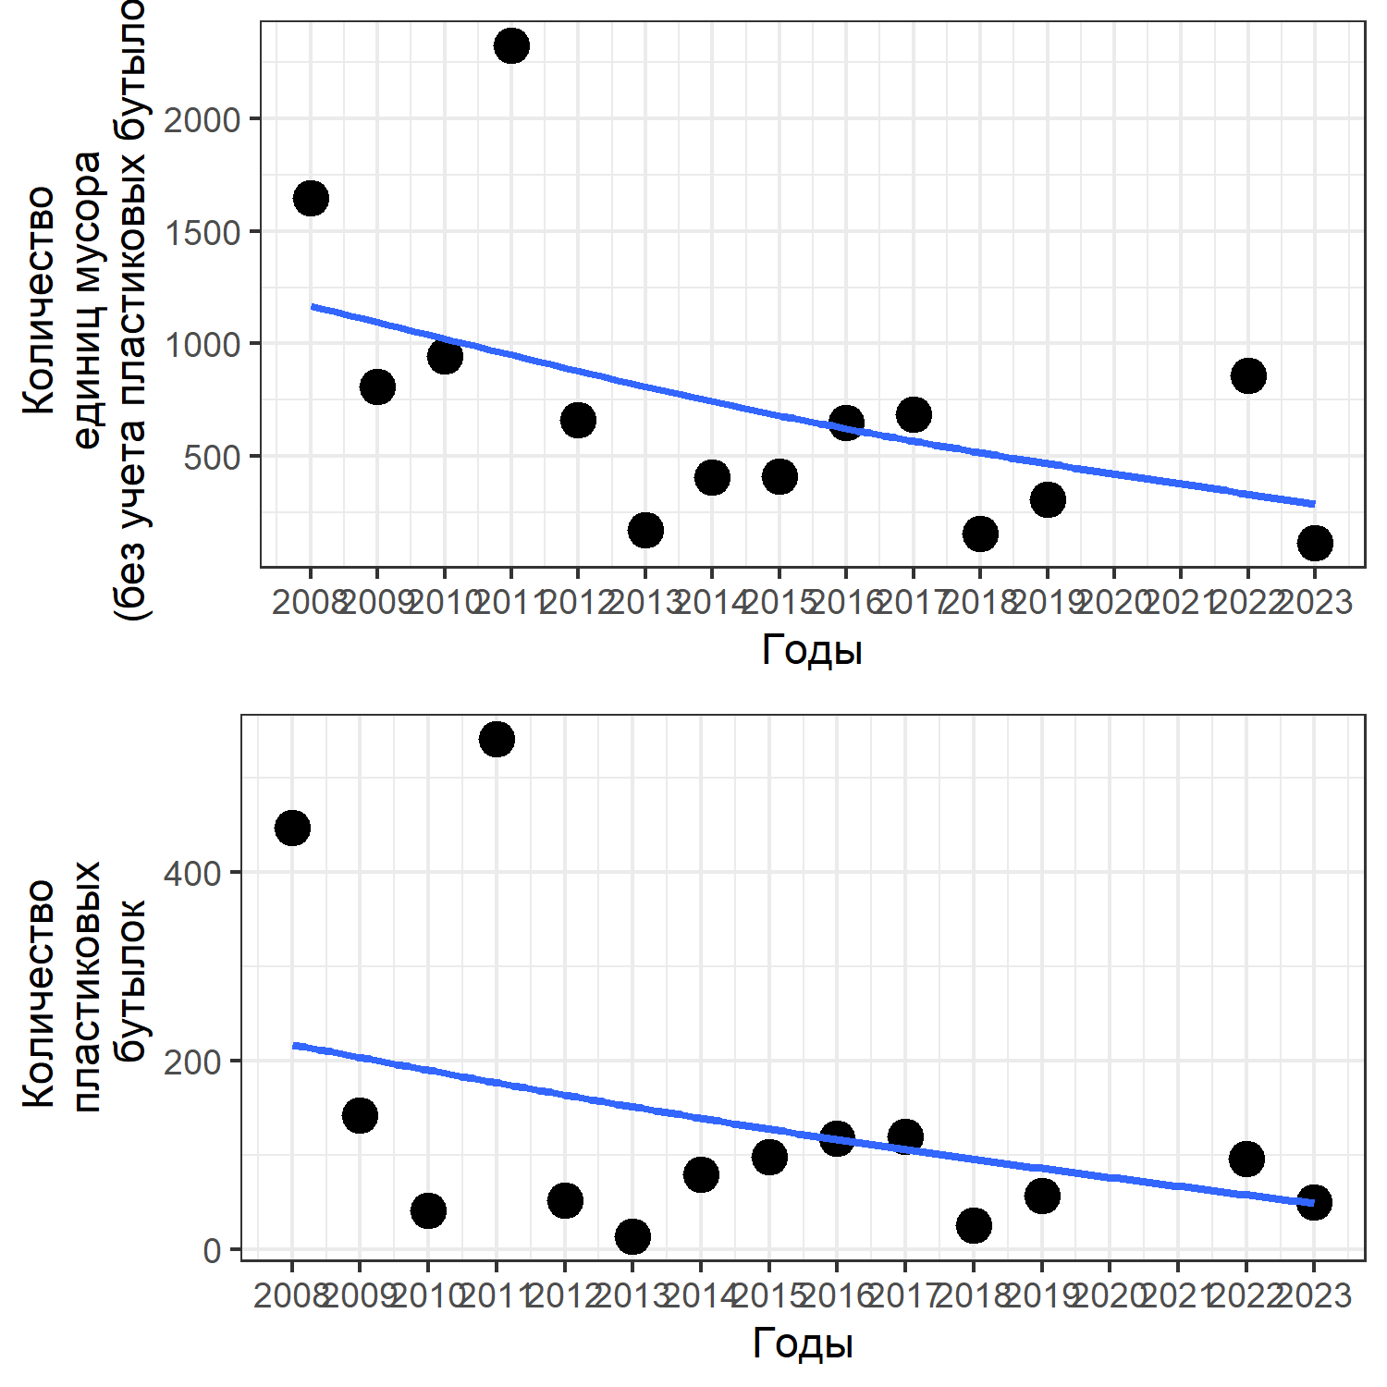

**Рисунок 1.** Общее количество единиц мусора и количество пластиковых бутылок обнаруженных на побережье о. Ряжкова в разные годы (приведена линия тренда). Total litter amount and number of plastic botles found on the shore of Ryazhkov island in different years (trend line is provided)

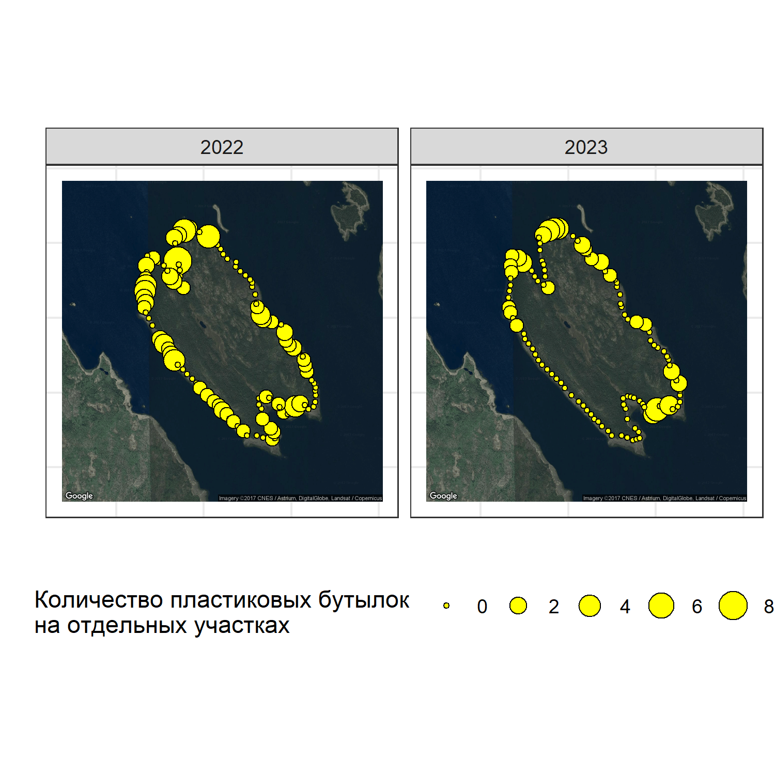

**Рисунок 2.** Распределение пластиковых бутылок на побережье о. Ряжкова в 2022-2023 гг. Patten of plastic botles distribution on the shore of Ryazhkov island шт 2022-2023